Experiment 8– Triggers
Objective
- Practical implementation of SQL triggers
- Learn how to Create/Alter/drop DML and DDL triggers
Overview:
A trigger is a special kind of stored procedure that automatically executes when an event occurs in the database server. An SQL trigger may call stored procedures or user-defined functions to perform additional processing when the trigger is executed.
Unlike stored procedures, an SQL trigger cannot be directly called from an application. Instead, an SQL trigger is invoked by the database management system on the execution of a triggering insert, update, or delete operation. The definition of the SQL trigger is stored in the database management system and is invoked by the database management system, when the SQL table, that the trigger is defined on, is modified.
Triggers can be divided into two main categories
- DML Triggers
- DDL Triggers

DML Triggers

DML triggers is a special type of stored procedure that automatically takes effect when a data manipulation language (DML) event takes place that affects the table or view defined in the trigger.
DML events include INSERT, UPDATE, or DELETE statements. DML triggers can be used to enforce business rules and data integrity, query other tables, and include complex Transact-SQL statements. The trigger and the statement that fires it are treated as a single transaction, which can be rolled back from within the trigger.

Basically, DML triggers are classified into two main types: -
(i) After Triggers (For Triggers)
(ii) Instead Of Triggers

Please run the script.sql file given in the Lab folder using your own database to create the table used for today’s lab.

After Triggers (For Triggers)

These triggers run after an insert, update or delete on a table. They are not supported for views.

Given below we have a trigger that is fired after an update on the table.

CREATE TRIGGER Trigger_ForUpdate
ON TriggerEmployee
FOR UPDATE
AS
UPDATE TriggerEmployee
SET Description = 'changed with For update trigger'
--WHERE EmployeeID= 1

To fire the trigger, we can perform update on table TriggerEmployee using

UPDATE TriggerEmployee
SET Name = 'New Name'
WHERE EmployeeID= 4

Select data from above table to see that the trigger fired and description got updated.

Similarly, we can make after triggers or For Triggers for insert and delete as well.

How to use inserted or deleted rows:

First refresh the TriggerEmployee table by running the script given below:
--refreshing the data
truncate table TriggerEmployee
insert into TriggerEmployee (Name, EmployeeID,ContactID,ManagerID,Gender,Description) values ('Ahmed',1,2,2,'M','xyz')
insert into TriggerEmployee (Name, EmployeeID,ContactID,ManagerID,Gender,Description) values ('Osama',2,1,2,'M','sadsd')
insert into TriggerEmployee (Name, EmployeeID,ContactID,ManagerID,Gender,Description) values ('Qasim',3,1,2,'M','sadsff')

select * from triggerEmployee
go

Now modify the Trigger_ForUpdate trigger by running the script given below:

alter TRIGGER Trigger_ForUpdate
ON TriggerEmployee
FOR UPDATE
AS
declare @Employeeid int -- variable declaration
-- get the value from the table of employee id that was updated
select @Employeeid=EmployeeID from inserted
UPDATE TriggerEmployee
SET Description = 'changed with For update trigger'
WHERE EmployeeID= @EmployeeID

go
UPDATE TriggerEmployee
SET Name = 'New Name'
WHERE EmployeeID= 2
go

select *from TriggerEmployee
go

Instead Of Triggers:

These can be used as an interceptor for anything that anyone tried to do on our table or view. If you define an Instead Of trigger on a table for the Delete operation, then try to delete rows, and they will not actually get deleted (unless you issue another delete instruction from within the trigger).
We have 3 types of instead of triggers.

(a) INSTEAD OF INSERT Trigger.
(b) INSTEAD OF UPDATE Trigger.
(c) INSTEAD OF DELETE Trigger.

Example of instead of insert trigger

create TRIGGER SampleTrigger_select
ON TriggerEmployee
INSTEAD OF INSERT
AS
SELECT * FROM TriggerEmployee
--print 'sorry this table cannot be modified'

go

INSERT INTO TriggerEmployee(EmployeeID,NAME,ContactID,ManagerID,Gender)
VALUES(5, 'Instead of insert "Select Trigger" ' , 1108, 1, 'M' )

go

SELECT * FROM TriggerEmployee -- NO CHANGE IN THE TABLE

Go

Instead of update and delete triggers can be made using similar way as well. Below is an example of an instead of delete trigger:

create TRIGGER T_DeleteEmployee
ON TriggerEmployee
INSTEAD OF delete
AS
IF
(
SELECT COUNT(*)
FROM TriggerEmployee A

) >0

BEGIN
PRINT 'CAN NOT BE deleted'
END

go

DELETE from TriggerEmployee WHERE EmployeeID= 1
go
select *From TriggerEmployee
go

DDL Triggers

DDL triggers, like regular triggers, fire stored procedures in response to an event. However, unlike DML triggers, they do not fire in response to UPDATE, INSERT, or DELETE statements on a table or view. Instead, they fire in response to a variety of Data Definition Language (DDL) events. These events primarily correspond to SQL statements that start with the keywords CREATE, ALTER, and DROP.

Use DDL triggers when you want to do the following:
- You want to prevent certain changes to your database schema.
- You want something to occur in the database in response to a change in your database schema.
- You want to record changes or events in the database schema.

Example of DDL trigger fired on drop_table event
CREATE TRIGGER T_DeleteTable
ON DatabASE
FOR DROP_TABLE
AS
PRINT 'CAN NOT BE dropped'
RollBack -- we dont have instead of in DDL so we use rollback
go

To fire the trigger we can try to drop any table of the database on which trigger was defined.
DROP TABLE TriggerEmployee
go

Example of DDL trigger fired on alter_table event

create TRIGGER T_AlterTable_DT
ON DatabASE
FOR ALTER_TABLE
AS
PRINT 'Table alterd succesfully'

go
To fire the trigger we can try to alter any table of the database on which trigger was defined.

ALTER TABLE TriggerEmployee ALTER COLUMN [NAME] VARCHAR(60)
-- select * from TriggerEmployee
go

To drop a DDL Trigger

drop trigger T_DeleteTable on database

InLab Exercise:

Please run the university.sql file using your own database before proceeding with the exercises.

- We have FAST university database in which we are keeping track of students and their departments and which course they are enrolled. The university hires you to make following changes to their database. The University Database script is placed in the manual folder.

- The academic officer is concerned with database auditing so he decides to maintain a record of changes made to database. Create a table Auditing in database with a column AuditId and LastChangeOn . Create triggers on student, department tables so that when ever any change is made on these tables the date of change gets stored in the Auditing table.
create table Auditing
(
AuditId int not null identity(1,1),
LastChangeOn date,
constraint AUDITINGPK primary key (AuditId)
)

create trigger T_StudentTrigger
on t_student
for insert, delete, update
as
declare @LastChangeOn date
select @LastChangeOn = convert(varchar(10), getdate(), 101)
insert into Auditing(LastChangeOn)
values (@LastChangeOn)

create trigger T_DepartmentTrigger
on t_department
for insert, delete, update
as
declare @LastChangeOn date
select @LastChangeOn = convert(varchar(10), getdate(), 101)
insert into Auditing(LastChangeOn)
values (@LastChangeOn)

insert into t_department(dept_name, building, budget)
values('A', 'BuildingA', 12000)

insert into t_student(ID, name, dept_name, tot_cred)
values('5443', 'Haasin', 'A', 16)

select * from Auditing

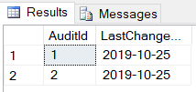

- Though academic officer was pretty much satisfied with your last change but after few months he feels something is missing in auditing table so he ask to change the structure of the audit table . So now he want to store proper information like

23/09/19 table updated with dep_name=ee
23/10/19 table deleted with dep_name=cs

So make appropriate change in triggers to perform the operation.

alter table Auditing add Description varchar(100)
select * from Auditing

--DEPARTMENT TRIGGERS
create trigger T_DepartmentInsert
on t_department
for insert
as
--storing date
declare @LastChangeOn date
select @LastChangeOn = convert(varchar(10), getdate(), 101)
--storing department name
declare @dept_name varchar(20)
select @dept_name = dept_name from inserted
--storing description
declare @Description varchar(100)
select @Description = 'table inserted with dep_name = ' + @dept_name
insert into Auditing(LastChangeOn, Description)
values (@LastChangeOn, @Description)

create trigger T_DepartmentDelete
on t_department
for delete
as
--storing date
declare @LastChangeOn date
select @LastChangeOn = convert(varchar(10), getdate(), 101)
--storing department name
declare @dep_name varchar(20)
select @dep_name = dept_name from deleted
--storing description
declare @Description varchar(100)
select @Description = 'table deleted with dep_name = ' + @dep_name
insert into Auditing(LastChangeOn, Description)
values (@LastChangeOn, @Description)

create trigger T_DepartmentUpdate
on t_department
for update
as
--storing date
declare @LastChangeOn date
select @LastChangeOn = convert(varchar(10), getdate(), 101)
--storing department name
declare @dept_name varchar(20)
select @dept_name = dept_name from inserted
--storing description
declare @Description varchar(100)
select @Description = 'table updated with dep_name = ' + @dept_name
insert into Auditing(LastChangeOn, Description)
values (@LastChangeOn, @Description)

--STUDENT TRIGGERS
create trigger T_StudentInsert
on t_student
for insert
as
--storing date
declare @LastChangeOn date
select @LastChangeOn = convert(varchar(10), getdate(), 101)
--storing student id
declare @ID varchar(5)
select @ID = ID from inserted
--storing description
declare @Description varchar(100)
select @Description = 'table inserted with ID = ' + @ID
insert into Auditing(LastChangeOn, Description)
values (@LastChangeOn, @Description)

create trigger T_StudentDelete
on t_student
for delete
as
--storing date
declare @LastChangeOn date
select @LastChangeOn = convert(varchar(10), getdate(), 101)
--storing student id
declare @ID varchar(5)
select @ID = ID from deleted
--storing description
declare @Description varchar(100)
select @Description = 'table deleted with ID = ' + @ID
insert into Auditing(LastChangeOn, Description)
values (@LastChangeOn, @Description)

create trigger T_StudentUpdated
on t_student
for update
as
--storing date
declare @LastChangeOn date
select @LastChangeOn = convert(varchar(10), getdate(), 101)
--storing student id
declare @ID varchar(5)
select @ID = ID from inserted
--storing description
declare @Description varchar(100)
select @Description = 'table updated with ID = ' + @ID
insert into Auditing(LastChangeOn, Description)
values (@LastChangeOn, @Description)

Student and Department tables

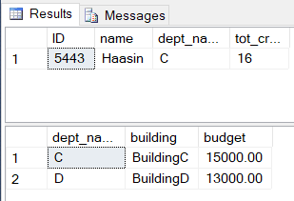

insert into t_department(dept_name, building, budget)
values('E', 'BuildingE', 12000)

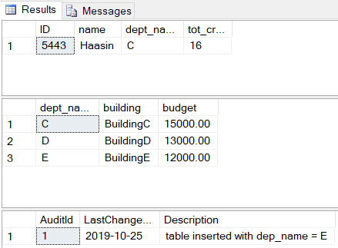

delete from t_department where dept_name = 'D'

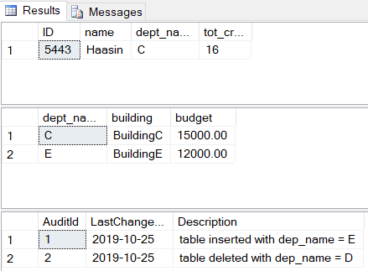

update t_student set dept_name = 'E' where ID = '5443'

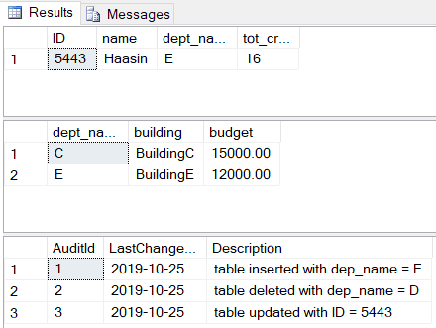

Post Lab Questions
- The academic officer also wants to make sure no one insert, update or deletes department information from the database. As university has only 3 departments CS, Business and Electrical and that are already present in database. So, create a trigger that will not let anyone to change the department table.
- The academic officer was very happy with your last changes in university database So he hires you again on contract basis to make few more changes to database. So perform following changes to the university database.
- The audit log we made will be useless if someone delete the record from it. So he wants to have a security measure on the table so that no one is able to delete any record or update any record from the Auditing table.

